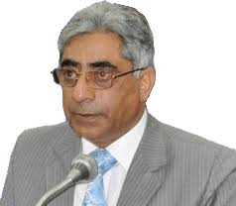**Ghulam Nabi Lone**

**About:** Jammu and Kashmir Education Minister Ghulam Nabi Lone was killed in a fidayeen (suicide) attack at his Tulsibagh area residence in Srinagar on Tuesday morning.Police said two fidayeen militants made their way into the high security area wearing police uniforms.The two stormed Dr Lone's house and opened fire indiscriminately, seriously injuring the minister who succumbed to his injuries in hospital.In the ensuing gun battle, two security men and a militant were killed. A civilian was also injured in the shootout, succumbed to his injuries later, taking the toll to 5. Five others, including two security men, were injured in the attack.

**Murdered on:**18 Oct 2005

**Attack details:** Nabi Lone was killed in a militant attack in the high-security Tulsibagh area of Srinagar.

**Reason to him target:** Jammu and Kashmir Minister of State for Education Tarigami, who is also CPI(M) state general secretary and his family members were present in the house when the militants struck.

**Occupation:** Jammu and Kashmir Education Minister.

**Belief:** Jammu and Kashmir Minister of State for Education.

**URL :** <https://www.kashmirpen.com/apathy-sericulture-departments-website-still-shows-ghulam-nabi-lone-as-its-minister/>

<https://thekashmirhorizon.com/2020/08/14/govt-systematically-hounding-kashmiri-youth-pdps-hanjura/>

<https://www.indiatoday.in/magazine/states/story/20051031-jammu-kashmir-minister-ghulam-nabi-lone-shot-dead-local-militants-claim-responsibility-786710-2005-10-31>

